**For OSX,**

1. open terminal
2. run “ssh -L1521:db17.cse.cuhk.edu.hk:1521 [xxx@gw.cse.cuhk.edu.hk](mailto:xxx@gw.cse.cuhk.edu.hk)” (replace xxx by username of CSE Account).
3. For Oracle server URL in SQL Workbench, use jdbc:oracle:thin://@127.0.0.1:1521/oradb.cse.cuhk.edu.hk instead of db17.cse.cuhk.edu.hk

**For Windows,**

1. open putty
2. input hostname gw.cse.cuhk.edu.hk
3. in Connection-> SSH -> Tunnels on the left side, set the source port and destination as follows, then click add. Then click open.

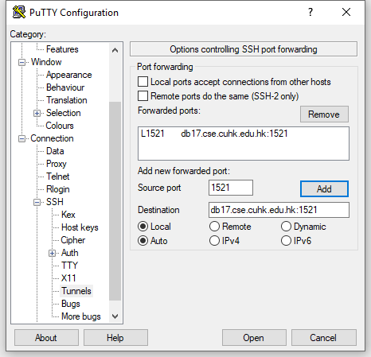

1. Login with CSE account.
2. For Oracle server URL in SQL Workbench, use jdbc:oracle:thin://@127.0.0.1:1521/oradb.cse.cuhk.edu.hk instead of db17.cse.cuhk.edu.hk